Website Updates (Final)

- Kindly take updated logos of ACIC-BMU from drive link given below.
Updated logos of ACIC-BMU

- Remove Samridh, Genesis, SISF from startups section.

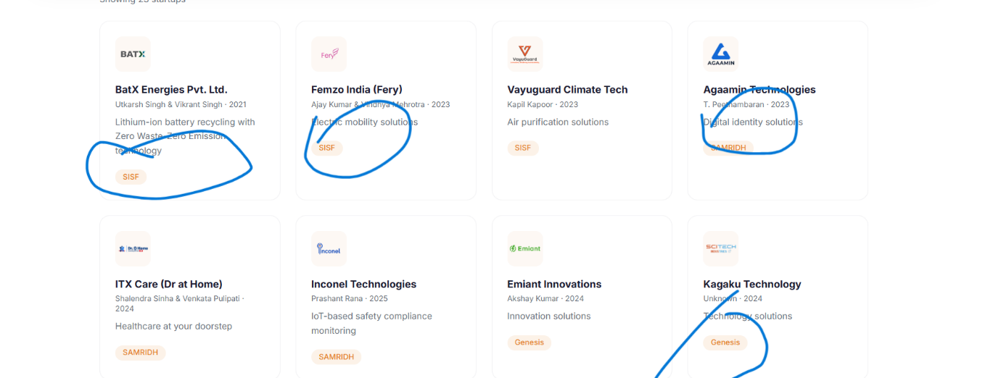

- Startup website link: Excel sheet attached with this email

- Add AIM intro in About Us after BML Munjal introduction.
Write: About Atal Innovation Mission
Atal Innovation Mission (AIM) is Government of India’s flagship initiative to create and promote a culture of innovation and entrepreneurship across the length and breadth of our country. AIM’s objective is to develop new programmes and policies for fostering innovation in different sectors of the economy, provide platforms and collaboration opportunities for different stakeholders, and create an umbrella structure to oversee the innovation & entrepreneurship ecosystem of the country.

- In Board Members:
- Change designation of Akshay Munjal to – Pro Chancellor BML Munjal University; Founder and CEO Hero Vired
- Change designation of Shyam Menon to – Officiating Vice Chancellor

- The profile pictures of all team members, board members, steering committee members, and mentors should be centered and consistent across the website. The images should have a uniform style, including the same framing, zoom level, and background. Currently, some photos are overly zoomed in, some have heads cropped, and the backgrounds vary. These can be standardized using AI to create a synchronized and professional appearance.

- In Sterring Committee members:

- Change name of Sunil Munjal to Sunil Kant Munjal. Designation- Chancellor BML Munjal University.
- Remove asterisk from Gerry George, Poyni Bhatt and Srinivas Rao.
- Kindly change designation of Poyni Bhat- Former CEO SINE
- Kindly change designation of Neharika Vohra- Former Board Member
- Kindly change designation of Srinivas Rao- Former CEO
- Kindly change name of Srinivas Rao to M Srinivas Rao
- Remove Swati Munjal from Sterring committee members
- In asterisk below, just write Former Member instead of Former Members
- Remove Governance from steering committee

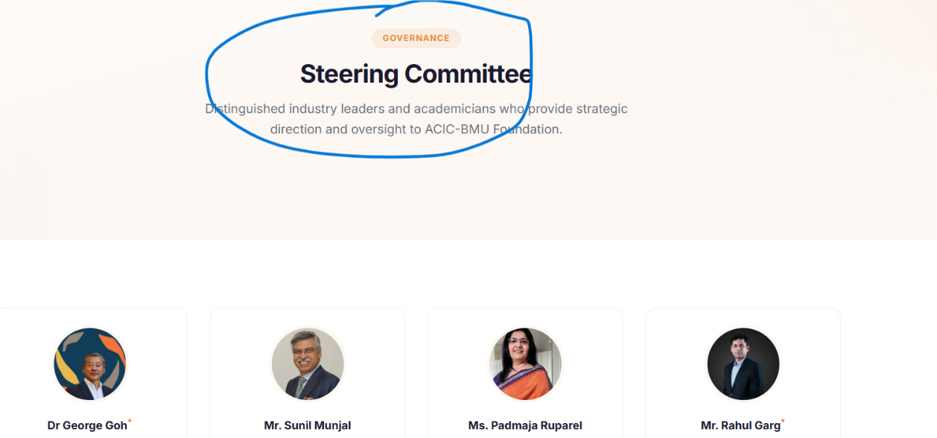

- Salutations are missing for some individuals. Salutations should be applied consistently across the website so that all names follow the same format and presentation.

- In Team Members:

- Remove Siraj Khan from the team members.
- Replace Ramanuj Jajoo with Ramanuj Jaju.

- 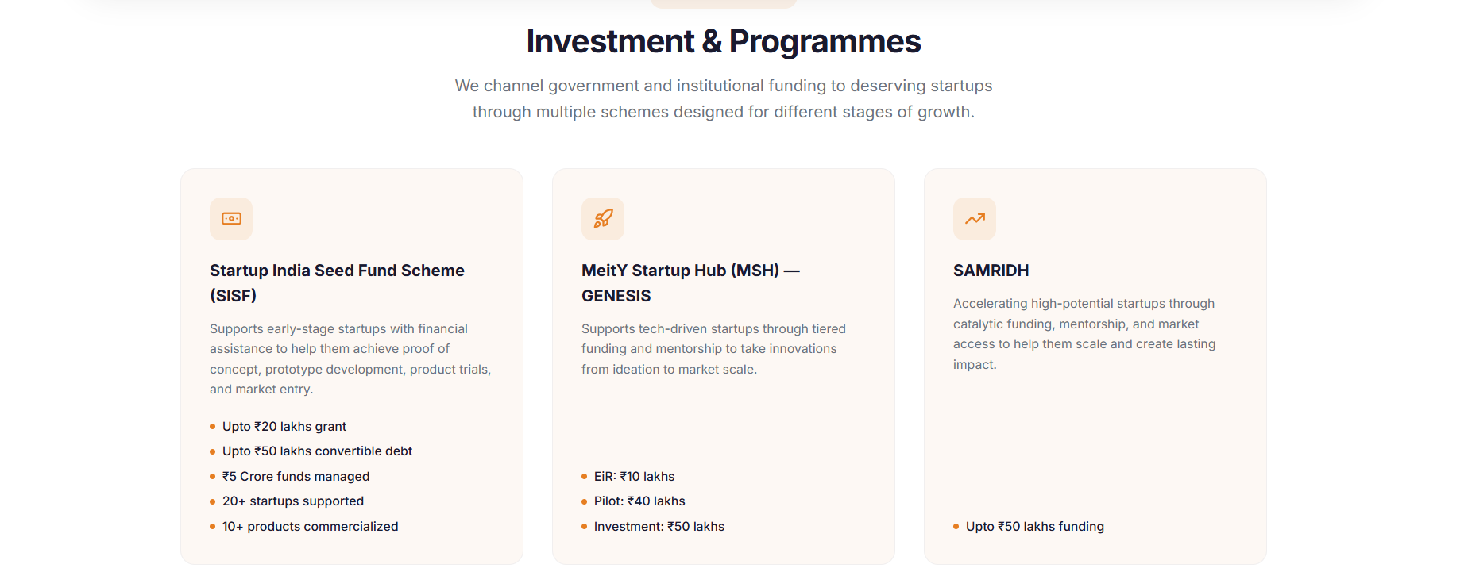

In this section:
- Write “Scheme guidelines applicable” at bottom of every scheme.
- Replace Investment and programme heading to Government Schemes.
- In Meity Startup Hub: Text is missing. There is text after EIR, Pilot and investment, we have to add that as well.
- The text is wrong in samridh. Kindly add that text only which is available in document.

- The text is wrong in Corporate programmes section. Kindly recheck.

- Remove vision and mission from yuva udyami program.

- 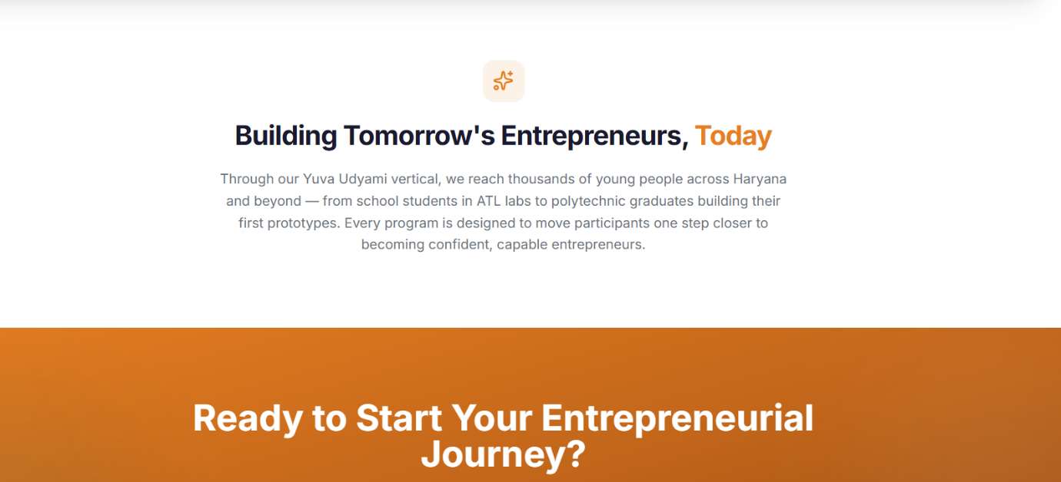

In yuva udyami program, remove this section as well.

- 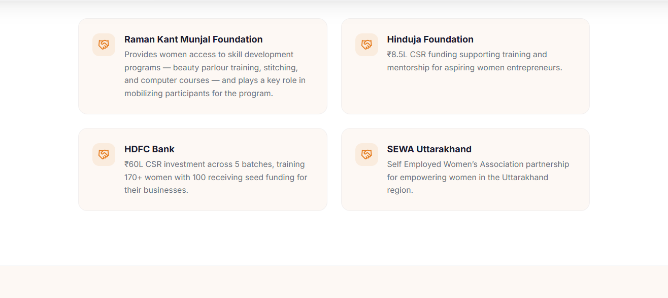
In Mera Business program, remove write up of all partners, just write their name.

- Remove Udaan from Corporate Programs and move to yuva udyami section.

- Remove the Partners tab. Show the partners on the homepage in a colorful sliding format. Also, remove India AI from the Partners section.

- Remove numbers from Event tab.

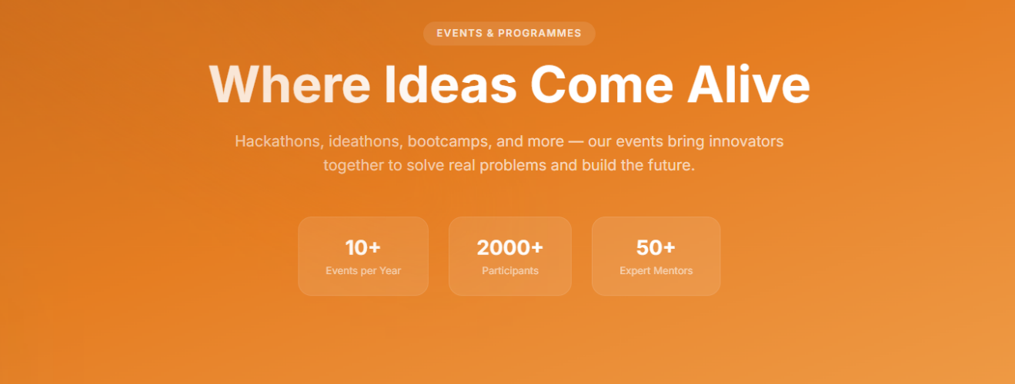

- We should remove this gap.
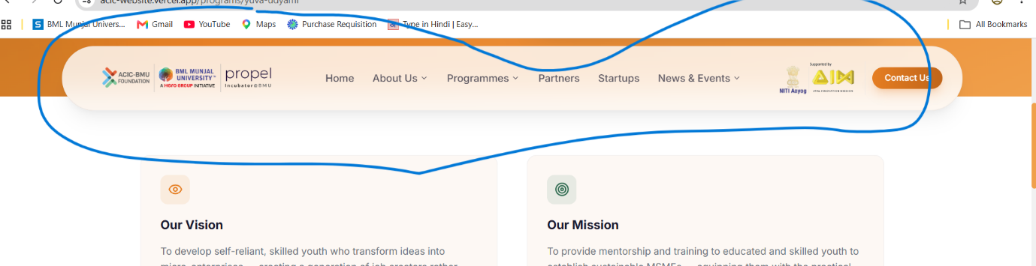

- The format of the numbers throughout the website should be same.
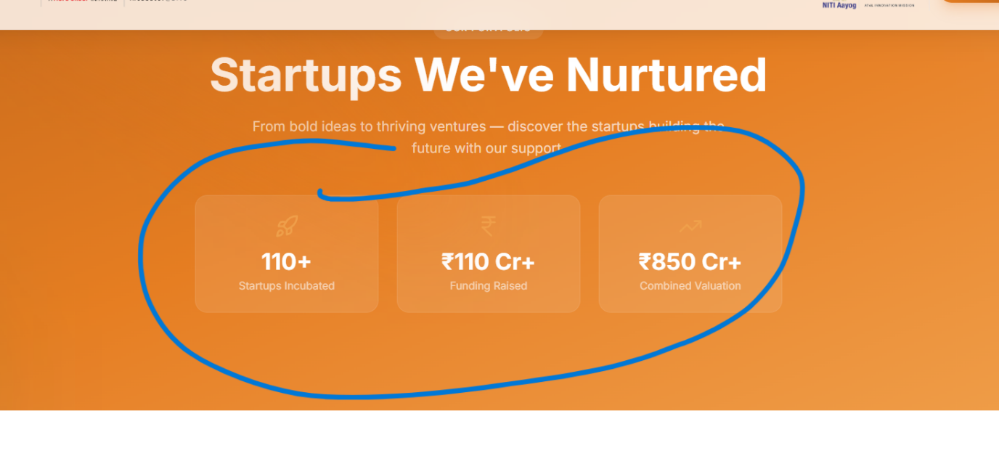
These numbers should be displayed as the number is displayed in mera business section, same goes for every program.

